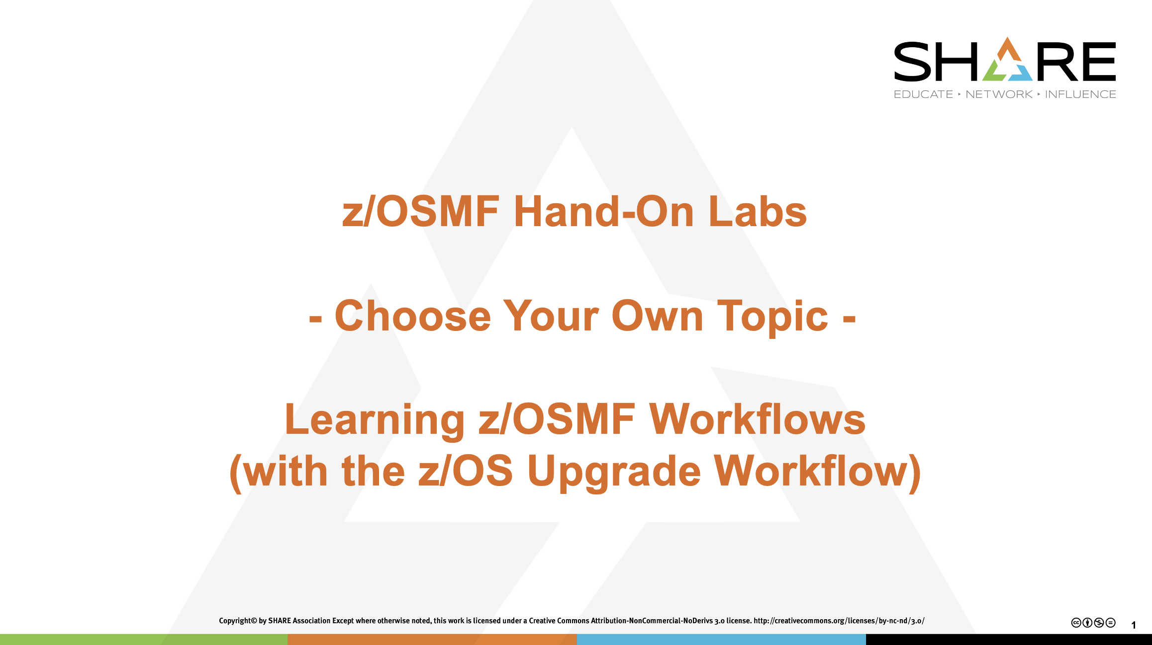
Introduction:
Want help with planning your z/OS 3.1 upgrade? You can have z/OSMF Workflow help you!
This lab is an introduction to using the z/OSMF Workflow function. You create a workflow, assign steps to different users, read notification messages, accept the assignment of a step, perform or skip a step, and provide feedback on a upgrade action (and the overall release upgrade).
Now included with z/OS: As of z/OS V2.5, IBM provides the z/OS Upgrade Workflow and the z/OS hardware server Upgrade Workflow as part of the z/OS product. Updates and fixes for the upgrade workflows are delivered through the standard z/OS service process.
To obtain the latest PTFs for the z/OS Upgrade Workflows, run the SMP/E REPORT MISSINGFIX command on your z/OS systems and specify a FIXCAT value of "IBM.Coexistence.z/OS.*". The z/OS 3.1 Upgrade Workflow can be run on z/OS releases V2.4, V2.5, and 3.1.
Our lab environment:
Be aware, you are running on z/OS 3.1 system and “performing” a z/OS 3.1 upgrade. It is meant to show you how to do a Workflow in general (and how you could use the z/OS 3.1 Upgrade Workflow in particular!).
On your own system, there might be some health checks to run for a 3.1 upgrade, that are not available on your V2.4/V2.5 system or receive an exception. That is fine, and is just to show you what a health check failure might look like during a Workflow. The object of this lab is to teach you to feel comfortable doing a z/OSMF Workflow.
You will see in this booklet the use of SHARA01 as the userid. Where you see this, you will have to substitute your own userid you were assigned.
[Unconditional]

Step 1: Logon to z/OSMF.
In this step, we will now go into z/OSMF to use the Workflow function. For this lab, we are using a z/OSMF 3.1 system.
- Go to https://share.centers.ihost.com/zosmf/ on Chrome, Firefox, or IE.
- Using the userid you were given (SHARAnn, SHARBnn, or SHARCnn) and the password, logon to z/OSMF. The userid you were given is a regular z/OS userid on this system, and has been given access to z/OSMF. There is no z/OSMF code on the workstation.
- Click on “Log in”.
https://share.centers.ihost.com/zosmf/
#1a

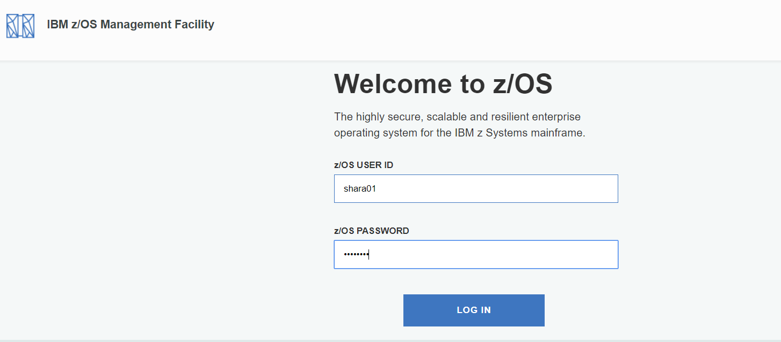
#1b
#2c

Enter into the Workflow function.
- Find and click on the “Workflows” icon.
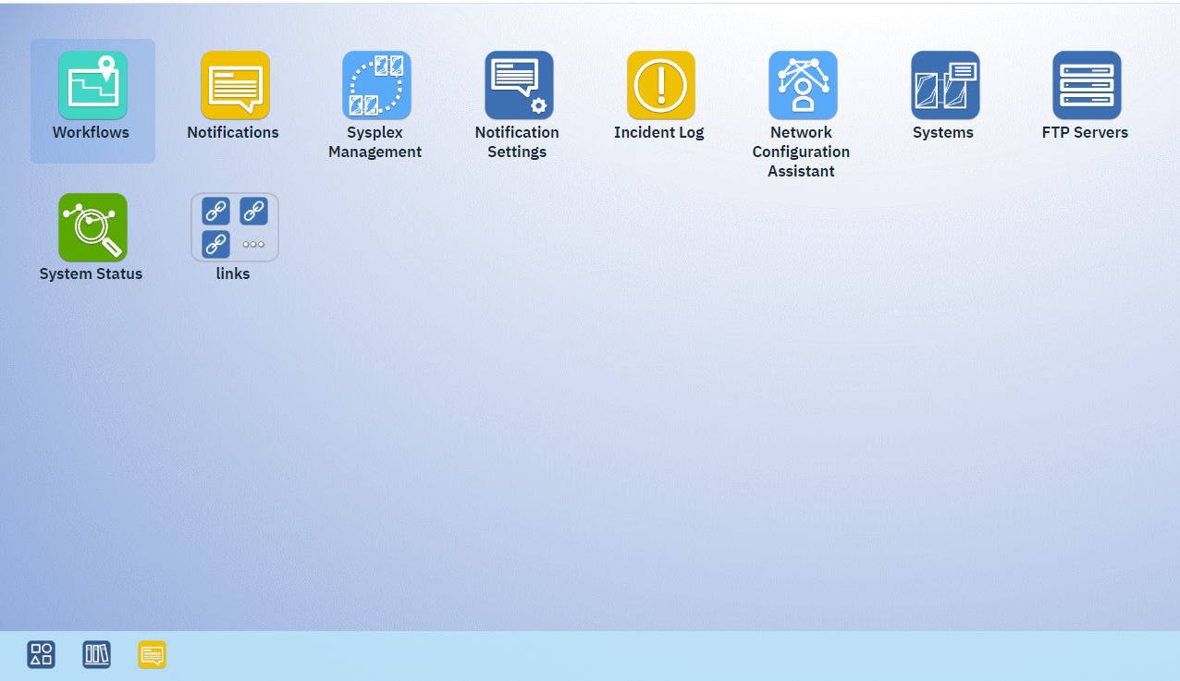
#1d

- This brings you into the main Workflow screen. You can see there are already some workflows created from this screen. You may resize this window to your liking.
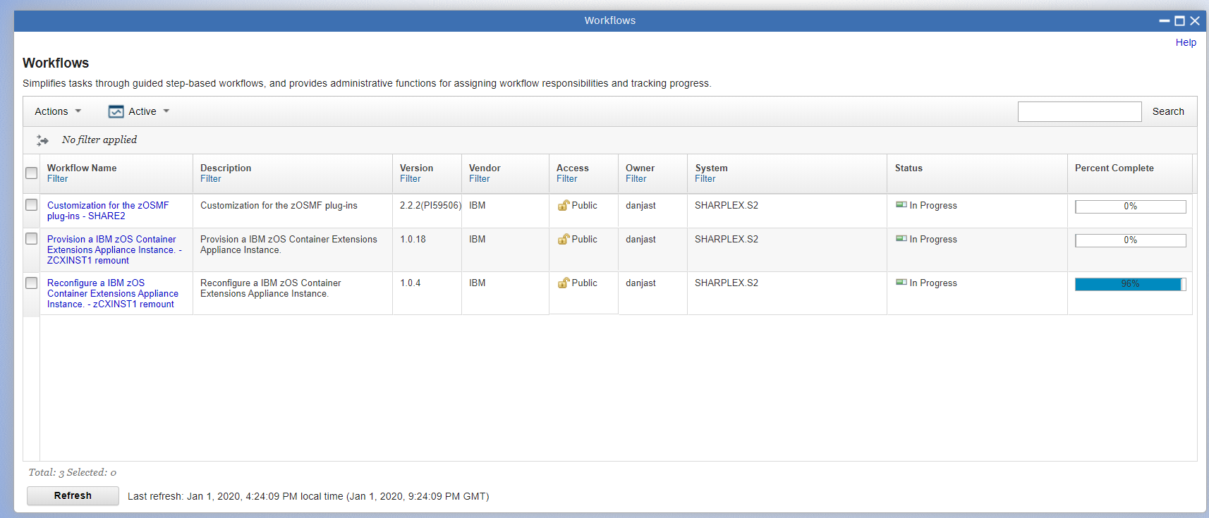

2.Create a z/OS 3.1 Upgrade Workflow instance.
In this step, we will create a specific workflow instance based on the supplied workflow definition file found on the lab system. When you upgrade to z/OS 3.1, you can find this workflow on your system in the same location, when you install z/OS 3.1 coexistence PTFs.
- Click on the Actions drop-down, then click on “Create Workflow…”

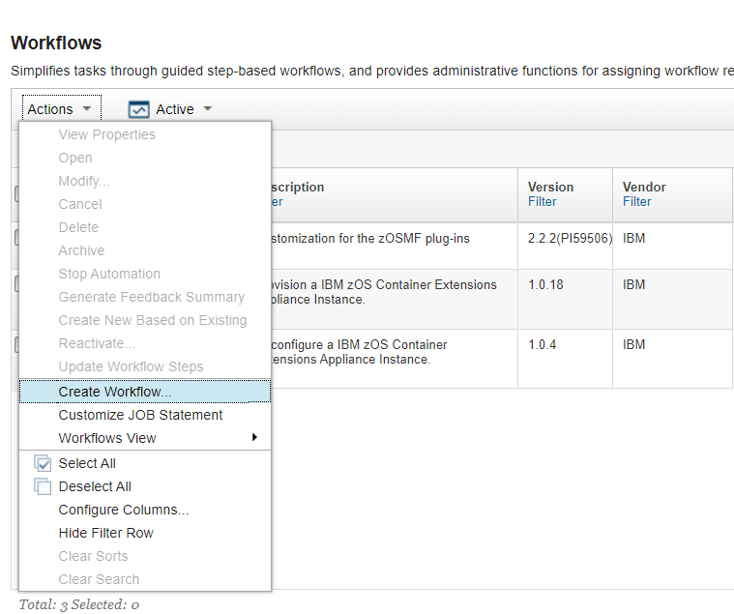
#2a

- Carefully enter in the location of the XML workflow file where the z/OS 3.1 Upgrade Workflow is found, where it says, “Workflow definition file:”. You only need to specify the XML file, as that one will pull in the other two files. The Workflow definition file for this lab is found here (pay attention to case).
/usr/lpp/bcp/upgrade/zOS_3.1_from_V2.5_Upgrade_Workflow.xml (for upgrades from V2.5 to 3.1)
Fyi: you would use /usr/lpp/bcp/upgrade/zOS_3.1_from_V2.4_Upgrade_Workflow.xml (for upgrades from V2.4 to 3.1)
If you don’t want to type the full name in, try to use the little magnifying glass to find it.
- For “System:”, on the dropdown, select “SHARPLEX.S2”, which might be the only choice. Leave “Workflow variable input file:” blank.
- Then click “Next >”. (“Leaving Workflow variable input file” blank.)
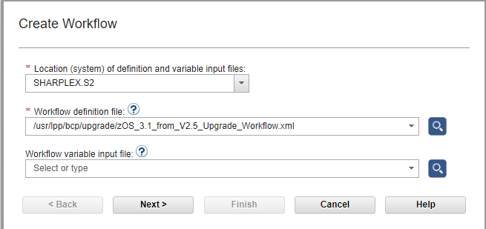
#2b
#2d
#2c

Name the workflow and identify the system.
At this point, we’ll provide some information about this workflow.
- Name your workflow instance: type a meaningful name under “Workflow name: “ of whatever you want, but please put your userid in the name so we know which workflows to remove later. You must name your workflow. (A suggested name: SHARAxx Upgrade Workflow Lab for zOS 3.1 , where SHARAxx is your designated userid.)
- Decide who you want the owner to be: type the owner’s name on “Owner user id:”. Usually, the owner would be the one that created the workflow, but you can make it some other user if you like. For this lab, keep it your assigned user ID. You must have an owner.
- Comments: put anything you wish here or leave it blank.
- Click “Finish” at this point. You might have to scroll a little to see the “Finish” box at the bottom of the window.
An Advanced Point! See the little checkbox “Assign all steps to owner user ID”? This is a very handy way of assigning all the steps (upgrade actions) initially to the owner. By doing this you immediately put all the steps into a “Ready” state for performing. Otherwise, you would have to assign steps, and have them accepted, to have them “Ready”. We are going to not check this box, so you can see more of the entire process. But if you wanted to save time, you might want to use this option on your own system.
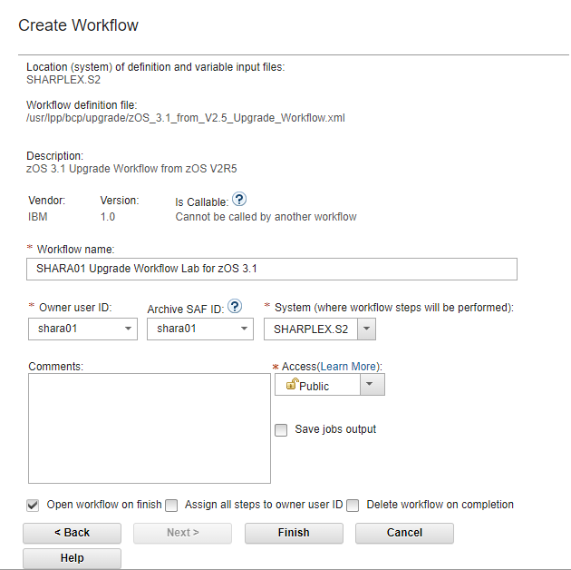
#2e
#3f
#3g
#3h

- Looking at the workflow overall.
There are some things to notice at this point if you untwist the “Workflow Details” at the top:
- There are 86 steps in this workflow. (The number of steps might vary, based on the PTF level of the Workflow which we are using.)
- You have completed 0% of them: 0 of 86 steps.
- There are 7 major (or “parent”) steps. This may be confusing, as there are sub-steps that count as steps in that 86 total. The first step to help you tailor or Workflow for what is in use on the system (Discover…), and the 7th step being the overall instructions for sending your feedback back to IBM.
- These steps are in a state of “Unassigned”, meaning that no one has been tasked with doing them yet.
- Notes and History: you can put any notes on this entire workflow here. Perhaps information on the entire schedule of this upgrade, or something else that is appropriate to make at the entire workflow level. Under History, you can see the history of this workflow: when it was created, who created it, etc.
#3e
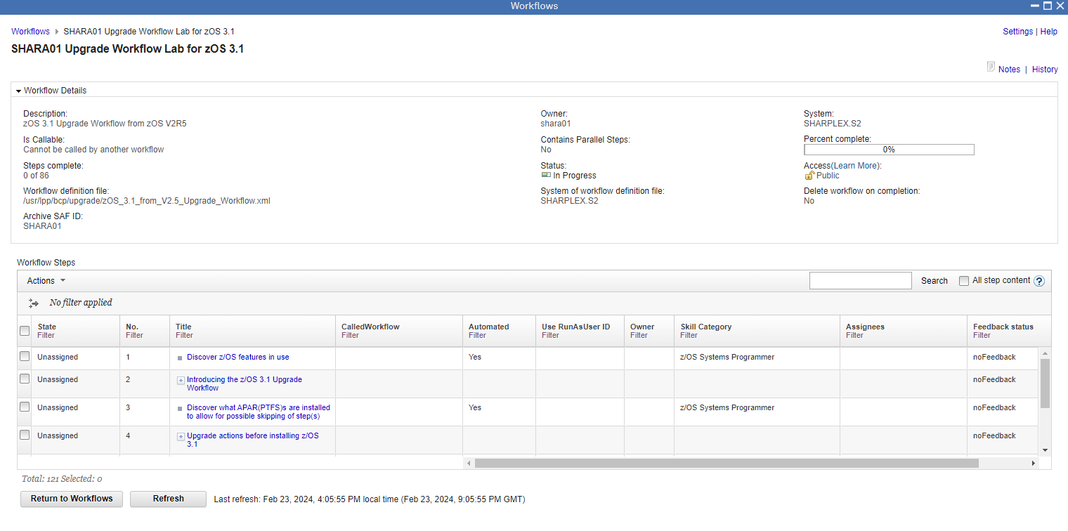
#3a
#3b
#3c
#3d
Click on Step 1 “Discover z/OS features in use” (the blue part) so that we can examine it.
There’s not much we can see, because we haven’t been assigned this step. Notice that the “Perform” tab has been grayed out. If we want to perform this step, we must be assigned to it, and must agree to do it.

Click on Close at the bottom to exit out.
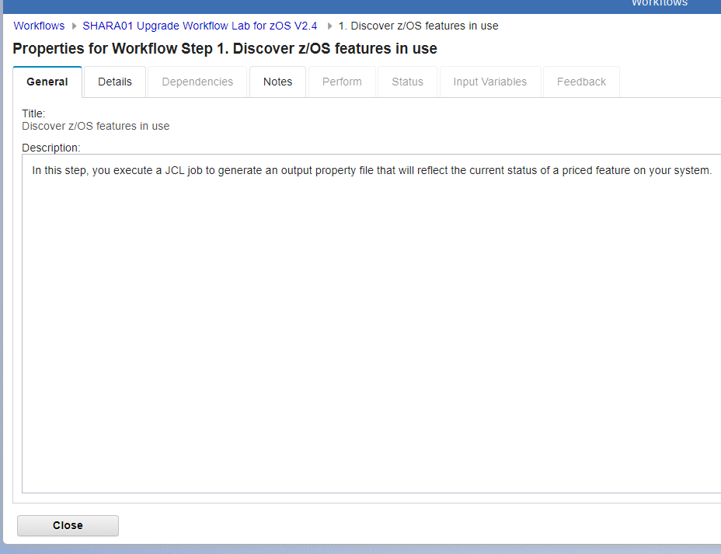

- Assigning a step.
Let’s get to the real work – assigning those steps to get them performed. You can assign a group of upgrade actions (say, all the Communications Server upgrade actions), or individual upgrade actions to one or more z/OSMF users. You select which steps to assign based on what steps are checked – a higher level step (which would include all the sub-steps), or on the smallest sub-step (“leaf”) itself. The idea is the same.
Let’s do the first step in the z/OS 3.1 Upgrade Workflow – the Discovery step. This step is a prerequisite for several other steps, so it is natural that it is first. (z/OSMF Workflow would tell you if you tried to execute a step that had a pre-req step and that pre-req step wasn’t completed.)
We will assign this Discovery step to a lucky person (ourselves) in this lab.
You should be back on the panel where the steps are shown:
- Click the box at the left of step 1 “Discovery z/OS features in use””.
- Then click on Actions -> Assignment and Ownership” -> “Add Assignees…”
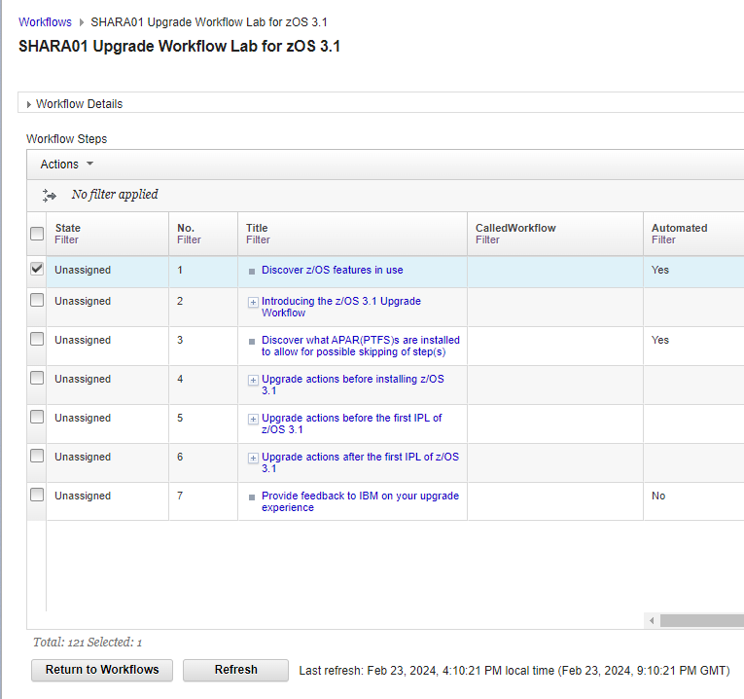
#4a
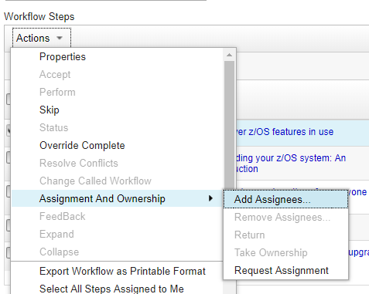
#4b

This is an interface you are probably familiar with.
- Click on userid in the list (SHARAnn, for instance), and if you wish, you can click on more than one userid. These people you add will be assigned to this upgrade action (step). If you don’t see your userid on the list…then add it! (Actions -> Add… -> then for SAF User ID, type your SHARAnn userid and “OK”. Now, it should appear on the list.). We are assigning to one person, so you can learn how to accept an upgrade action (step) assigned to you.
- Click on the “Add >” button and see that one person has been added to the yellow box on the right. You could assign this step to multiple people if you wanted.
- Type a friendly note, if you want, and then click on “OK”. If you left the “Send z/OSMF notifications to assignees…” box checked, this person will be notified he/she has something to do. The Notification is sent.
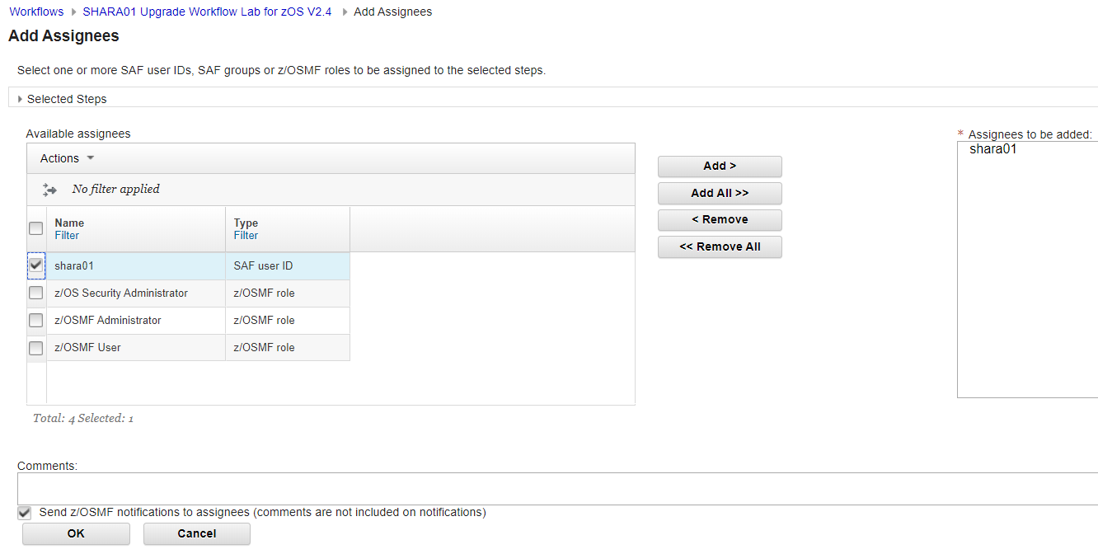
#4c
#4e
#4d

- Now you are back into the workflow. Scroll to the columns on the right, until you see “Assignees”. You can see the name you put there.
- Notice also that the State is now “Assigned” on all this section’s upgrade actions (steps), because we selected the entire section’s parent step.
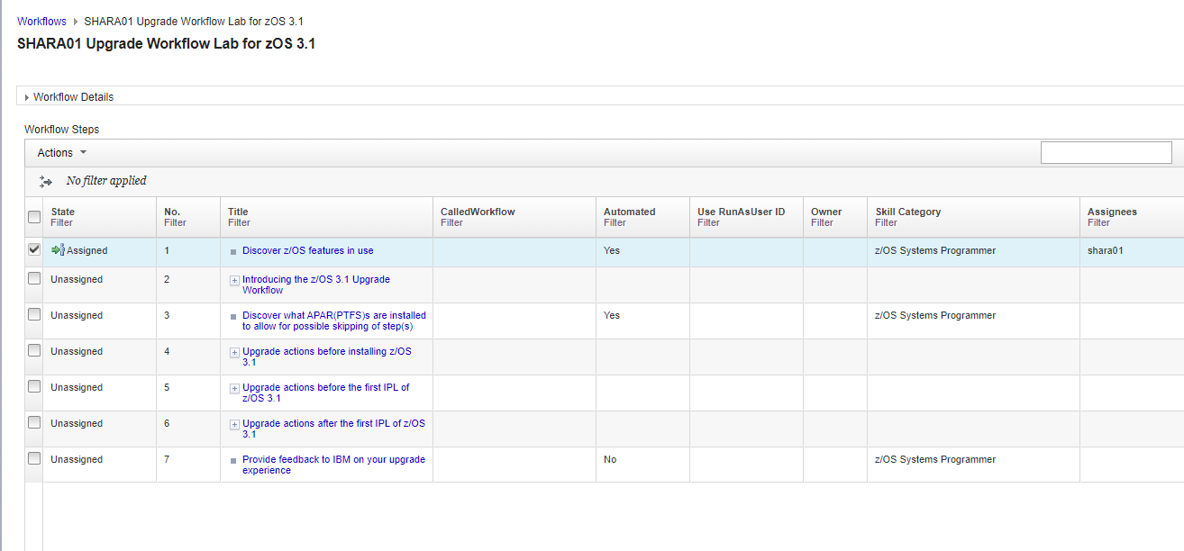
#4f
#4g

- Accepting a step.
“Assigned” isn’t enough to perform an action (step). The step also needs to be Accepted by the assignee.
Let’s see how to find what was assigned to our userid and how to use workflow filtering, which is very powerful. Scroll to the right to find the “Assignees” column and click on “Filter”. This would be helpful if many different people were assigned a step in a large workflow.
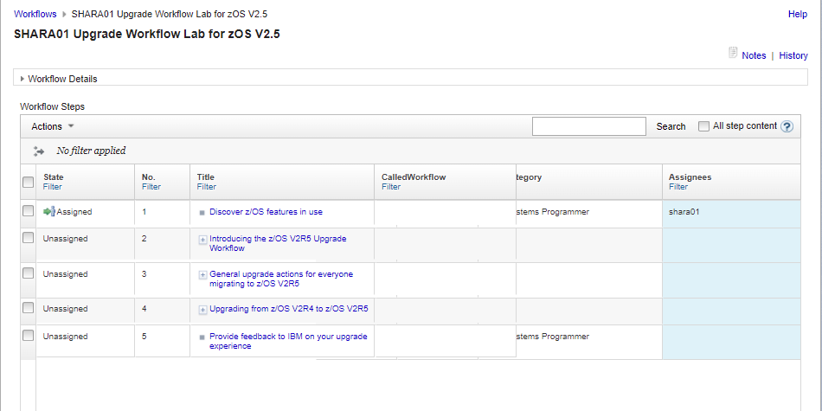

Then, under the “Assignees” blank area on the right, type your userid (SHARAnn, SHARBnn, SHARCnn), to filter on upgrade actions that are assigned to you, and then click on “Filter”.
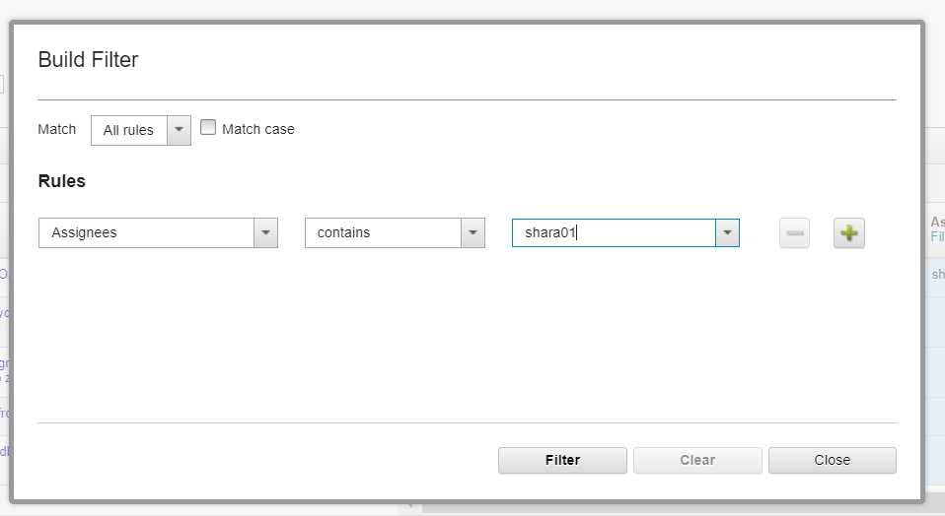

- You should see only the steps that are assigned to you because of the filter. We are going to accept the step assigned to us. Check the step 1 box (“Discover z/OS features in use”).
- Then click on the “Actions” drop-down, then “Accept”. If “Accept” is grayed out, you have not selected any steps, so verify that step 1 has a check on it before trying to do an action on it.
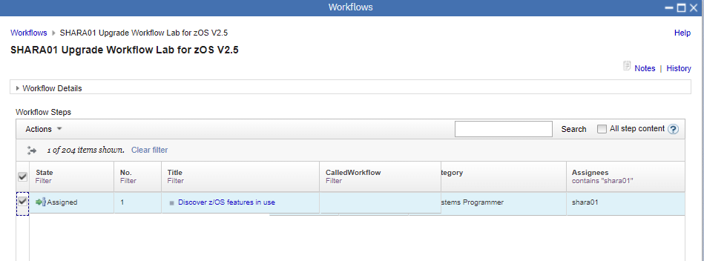
#5b
#5b

- You can make a comment when you accept any steps, then click on OK.
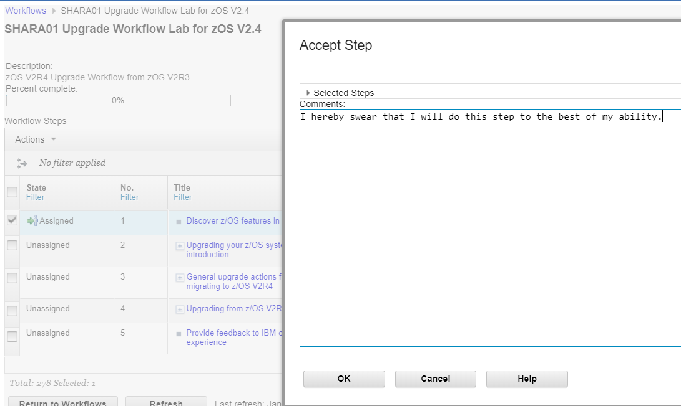
#5c
You see now that the state of step 1 is “Ready”. If you don’t see “Ready”, there was a problem with assignment and acceptance. Let’s perform this step now.
Click on the blue part of “Discover z/OS features in use” to open up the step.
(You might want to remove your Filter in the Assignee column so you can see the entire workflow instance again. Filter, then Clear in the pop-up.)
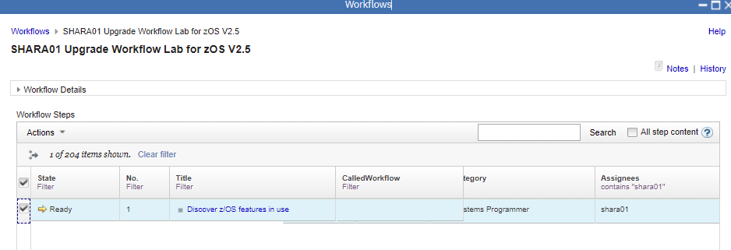
Now, since the step was assigned and accepted, you can see that the Perform tab can be clicked on. Click on the Perform tab:
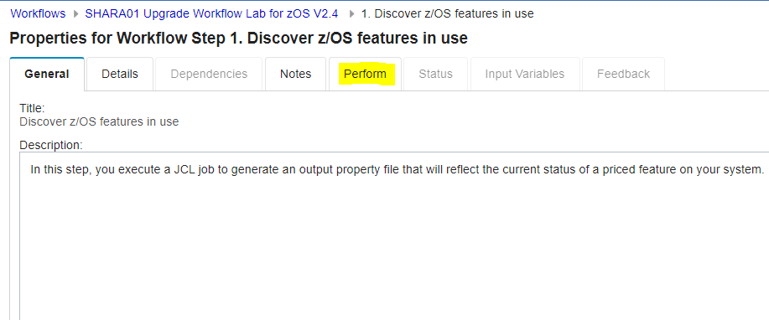

The reason why we have selected this Workflow for our lab is because it shows you how a workflow can do some discovery to skip certain steps you don’t need to do.

Following along with the guidance on the left-hand side, we are going to Review Instructions now. This step tells us what will happen when the discovery job is run. Read this information. Click on Next.
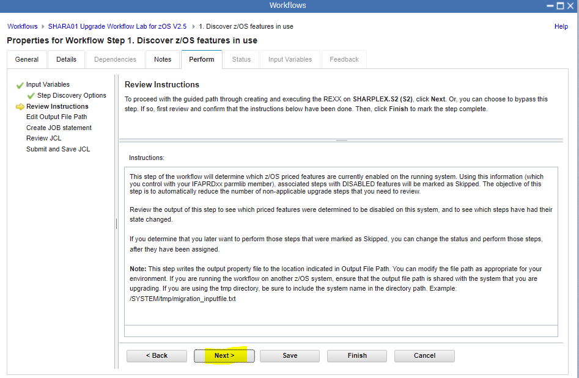

You must provide an Output File Path. This job will need to write some information that the workflow will need. There is a default provided, but you should supply your own unique one, since many people are probably doing this lab at the same time, and we would all overlay each other. Put your assigned userid in the field, so yours is unique, such as /tmp/shara01_migration_inputfile.txt where shara01 is your userid. Then click on Next.
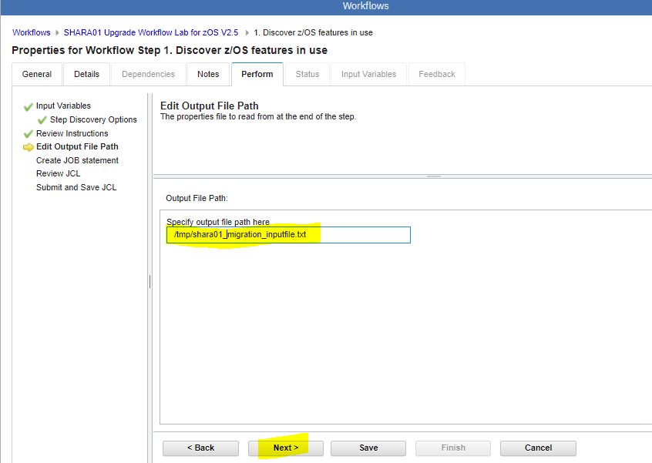

We are almost ready to submit our discovery job. The next is the jobcard. You can keep that as you wish, or perhaps change the jobname because the default is not very helpful. Also, it is helpful that if you change to jobcard, make it applicable to all future jobs in this workflow if you like. Then click Next.
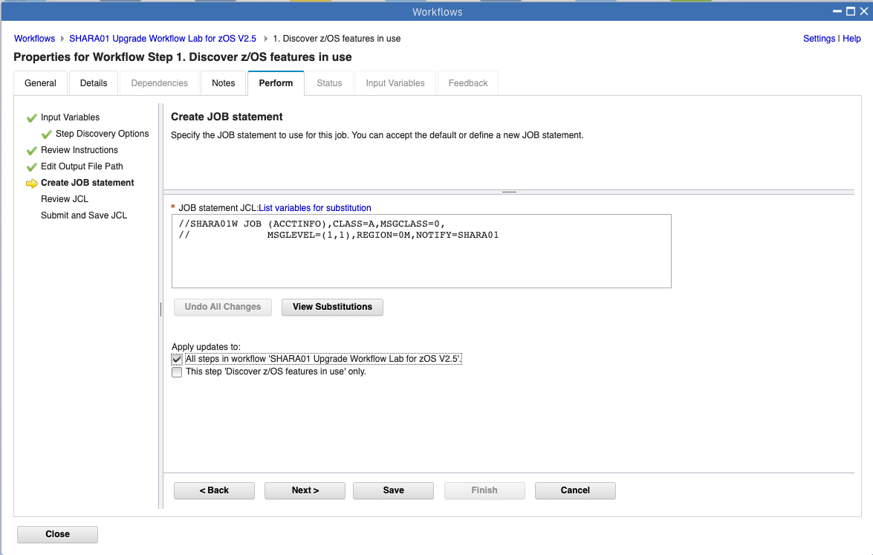

Then review the JCL. You should not need to edit it, but you can browse it if you like. Then click Next.
Now, the job will be submitted. Click on Finish.
The job was submitted! It should run quickly, but click on Refresh, if you don’t see it done.
Where is this job running? This is a normal JCL batch job that MVS is running on the host system under your userid. If you wanted to look at it under your spool product (like SDSF) you could. z/OSMF is just handling the submission and retrieval of the job for you.
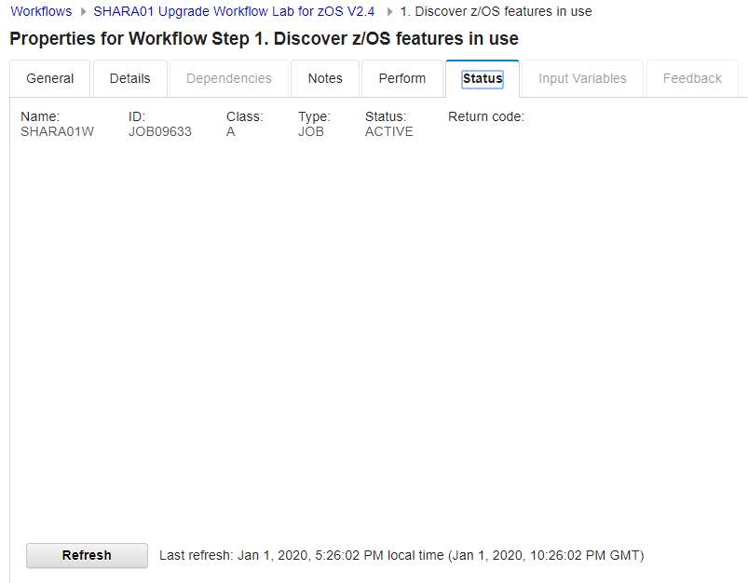

After the job has run, you should see some Status. Click on Status. (If you don’t see anything, click on “Refresh” to see if it has finished.)
You can click on each of the tabs to see the output from the job. You should see return codes of 0000 for both steps – GENER and RUNIT. Click on Close when you are satisfied.
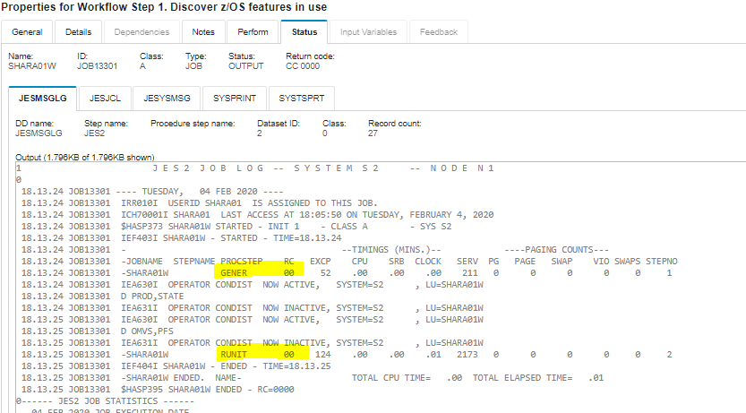

At this point, something interesting has happened. If you untwist the Workflow Details, look how 4 of 86 steps are completed, and 4% of our work is done! That is the beauty of discovery, because not applicable steps have been skipped. (You can still view them if you want, or even perform them, but that is your choice.)

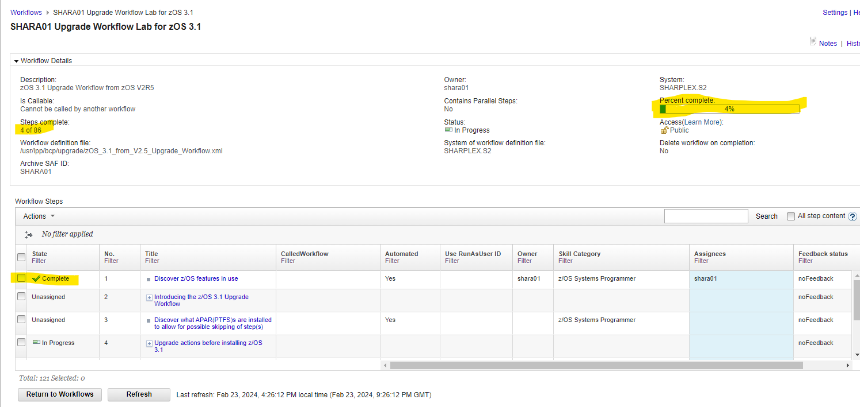

6a. Do another step by yourself.
You know the basics now. Let’s test your skills. Do another workflow step all by yourself (with the guidance below). This step you are doing will show off the capability to invoke a IBM Health Check for z/OS from within a workflow step and mark the step according to whether it was success (Complete) or an exception (Failed).

- Find step 4.1.6 “Verify you have enough XCF groups and XCF group members” in your workflow. You might have to do some untwisting to find it, but use the numbering scheme to help you find it. (Hint: step 4, step 4.1, step 4.1.6 – keep untwisting until you find 3.1.1.6.) Or you could filter on “XCF groups” in the title column or from the search box.
- Assign yourself to step 4.1.6. (Hint: start with the Actions drop down.)
- Accept step 4.1.6. (Hint: start with the Actions drop down.)
- Read the upgrade action under the “General” tab. For the z/OS Upgrade Workflow, you should always read the “General” tab to understand the upgrade action, and to perhaps manually perform it.
- Perform step 4.1.6. (There will be no questions to answer for this step.)
- What was the result of this health check associated with this step? (Hint: look at the output in Status under SYSTSPRT.)
  - If it was successful, did you see the step marked as Complete?
  - If it was an exception, did you see the step marked as Failed?

In general, for any Workflow, if you find that a step is failed, you’ll need to fix the condition that made it fail and re-run the step until it is Complete.
Usually, on this lab system, this health check completes successfully so you will see the workflow step marked as Complete.
You can continue to Assign → Accept → Perform other steps as you wish. In this specific Workflow, some steps invoke health checks, and some do not. It depends on the step and what is related to that z/OS 3.1 Upgrade action.

It really is that easy as you know have the basics understood.

Provide feedback to the workflow author!
Many times, a workflow author might want to provide the capability for you to provide your feedback about his/her workflow. You can do that with the Feedback tab, once you’re inside a workflow step, and you have Accepted the step. (The Feedback folder will be grayed out if the step isn’t ready to be performed.)
We always welcome comments about your z/OS 3.1 Upgrade experience, and this is a great time to just that, as the step is fresh in your mind! Pick a step you have Performed (like Step 4.1.6).
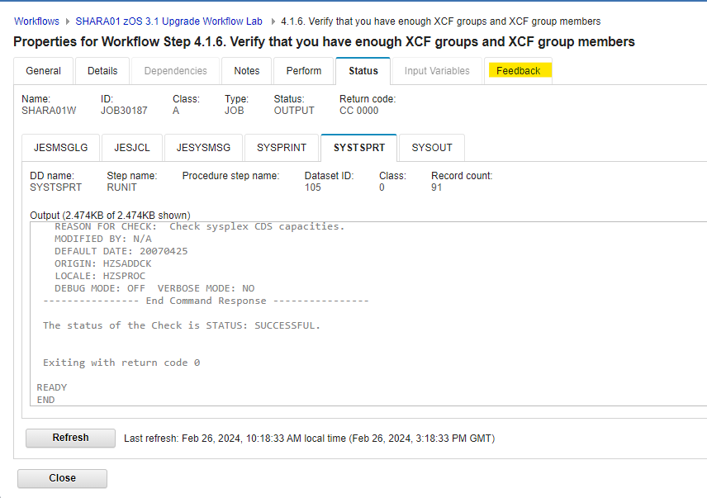
- Click on the Feedback tab for any step in the workflow. If you want to give feedback on the step, answer any of the questions you like. Save will just save your results so you can add more later. Submit “turns in” your results and you cannot change your answers after they have been submitted.

Let’s Submit and then OK so we can see what we will gather later.
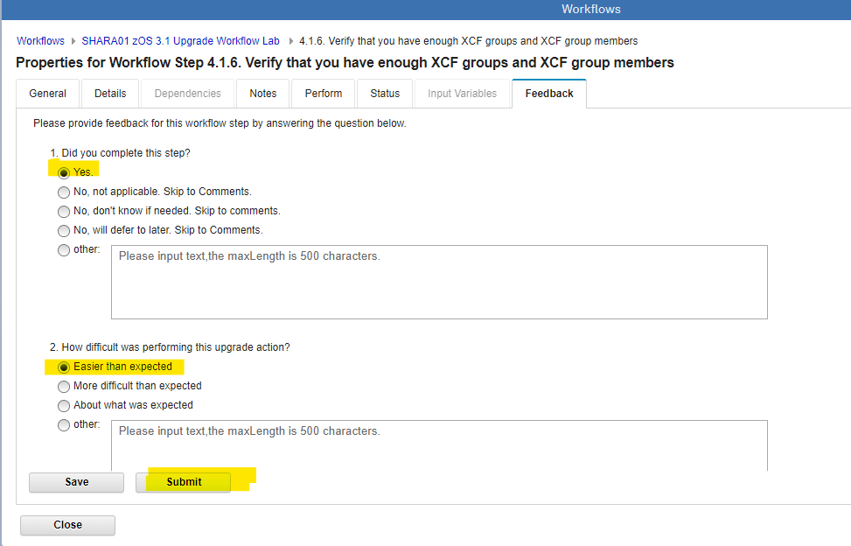

For this z/OS 3.1 Upgrade Workflow, the very last step of the workflow is asking about the overall z/OS release upgrade experience (Step 7, “Provide feedback to IBM on your upgrade experience.”). If you wish to provide your feedback on the entire z/OS upgrade experience, this the spot to do that.
- Perform (making sure to Assign and Accept the step) this last step 7. This step will also give you instructions on how to email all your feedback results to IBM, on the “Review instructions” location.
- Collecting your feedback to send to IBM. Once your feedback from all the steps is collected, you can then collect it to send back to IBM. This is easy to do. “Return to Workflows” (at the bottom to exit from this z/OS 3.1 Upgrade Workflow, to return to the overall Workflow screen.) You are now back on the main Workflow screen. Make sure the workflow you want to collect feedback on is checked:
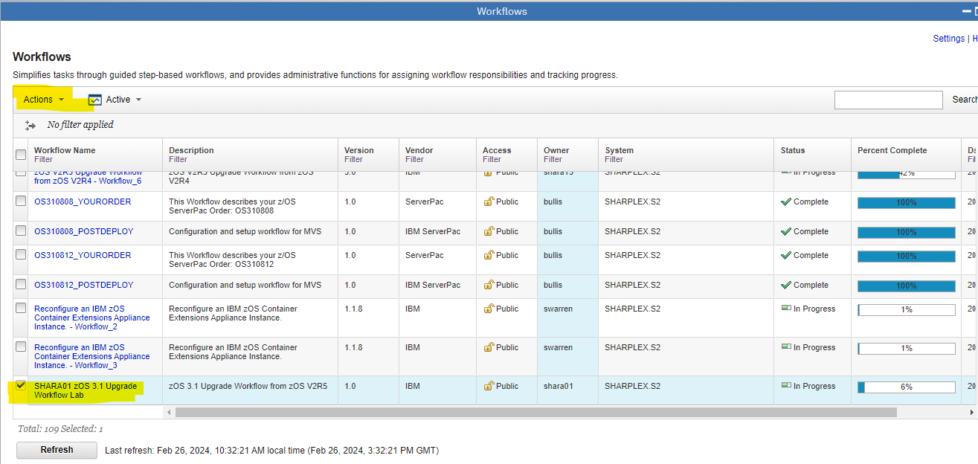

- Click Actions → Generate feedback summary.
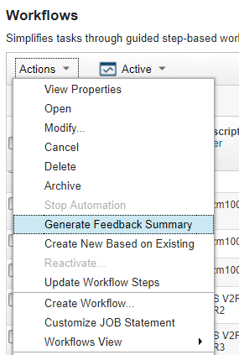

- You can now see everything that was collected in a simple readable text file. You can also notice that some step owners may not have completed feedback, and you can Notify Step Owners at this time. This will remind them to do feedback before you send the actual feedback to the Workflow owner.
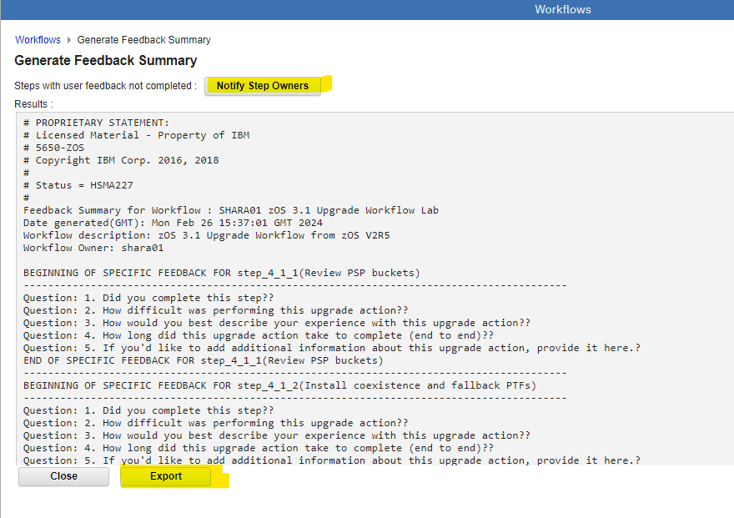

- Click on Export to put this data into a simple text file and it will be automatically downloaded to your workstation. You can edit this simple text file to remove any information you do not wish to share at this time. Click on it to see what it has gathered. Do you see your feedback from the steps you did Feedback on?
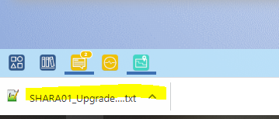
- Send back to IBM (to zosmig@us.ibm.com) if you wish! We welcome your feedback!

Please clean up from your lab, as we like a tidy lab system 😊 Back on the Workflows main panel, select your Workflow, then select the Workflow and then Actions-> Delete.
Thank you for tidying up.

Exercise review and wrap-up
By completion of this lab, you now know how to:
- Logon to z/OSMF. Enter into the Workflow function. You know what the Notification function is, and how to use it.
- Create a z/OS 3.1 Upgrade Workflow within z/OSMF.
- Look at some of the z/OSMF workflow functions, and generally how to maneuver around a workflow. Understanding the concept of states and steps (and sub-steps). Understand what the tabs for a step (z/OS upgrade action) are, and how they are used.
- Assign steps (upgrade actions) to different users.
- Accept the assignment of a step (upgrade action).
- Perform a step (upgrade action).
- Provide feedback for a workflow, and how to provide feedback for the entire release, if you like.

End of exercise

